Romanova Inna

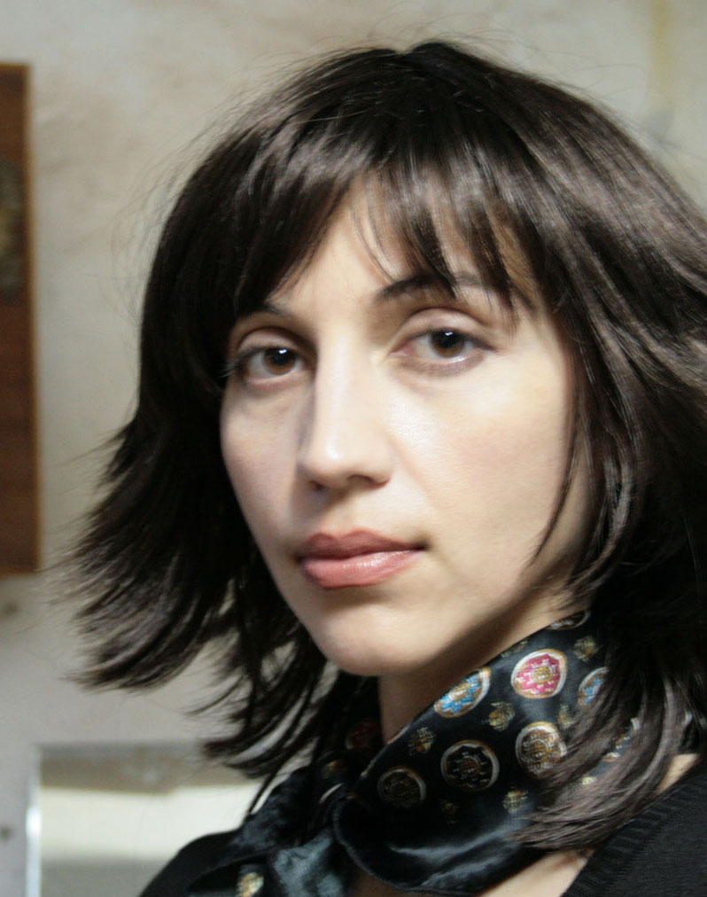 Romanova Inna

Birth date and birth place. 4 August ,1971, Poltava, Ukraine
Higher education. Was graduated of Kuban State University, Faculty of Arts
Member of the Union of artists of Russia .
Took part in more than 30 exhibitions
It works are in State and private collections of Russia and in private collections abroad Russia.
Lives and works in Russia, Krasnodar.

The frequent participant of cultural actions in Russia and abroad

Description of the artworks:

1. “The Fish Methuselah”
Cotton paper, acrylic, rivets, varnish
130/70см
2021

2. “The Horse Archer”
50/54см
cotton paper, , acrylic rivets metal, oil pencil
2020

3. “The Armed Lion"
50/60 см
cotton paper, , acrylic, rivets metal, oil pencil
2020

